# Exercises: HTML Structure

Problems for exercises and homework for the “HTML and CSS” course @ SoftUni. Submit your solutions in the SoftUni judge system at <https://judge.softuni.bg/Contests/396/HTML-Structure>.

## Simple Navigation Bar

Create a Web Page like the following:

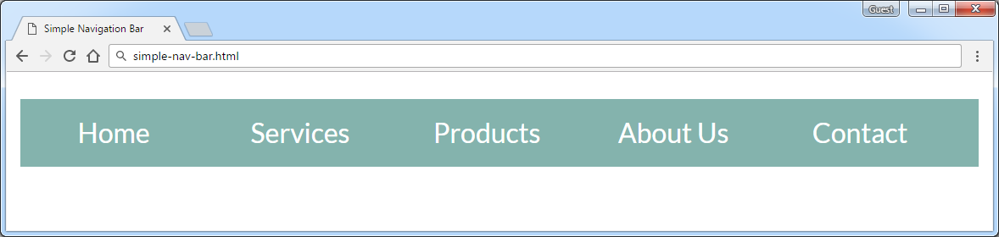

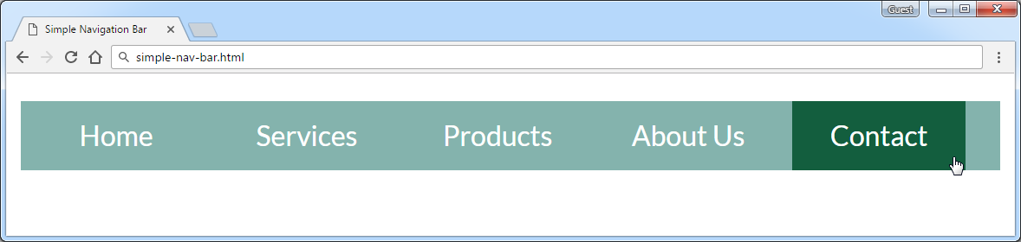

Create two files: "**simple-nav-bar.html**" and "**simple-nav-bar.css**".

### Constraints

* <body>
  + **font-family: "Lato", sans-serif;**
* <nav>tag as container
* Unordered List
  + Padding 0
  + Heigth 40px
  + Line Heigth 30px
  + Background Color #84b3ad
* <li> tag for list item
  + Width 100px
  + Margin 0 5px
  + Padding 5px 0
  + Cursor **pointer**
  + Text color #ffffff
  + Center the text
* <li>on hover
  + Background Color #135e3e
  + Padding 5px 0

### Hints

* <li> with display:inline-block;in the CSS file
* Put in your CSS all @font-face definitions from <https://fonts.googleapis.com/css?family=Lato:300,400,900>

Your **HTML** file might look like this:

|  |
| --- |
| **simple-nav-bar.html** |
| <!DOCTYPE html> <**html**> <**head**>  <**title**>Simple Navigation Bar</**title**>  <**link rel="stylesheet" href="simple-nav-bar.css"**> </**head**> <**body**>  **<nav>  <ul>**  **<li>**Home**</li>  *<--TODO: put the rest of list item here -->***  **</ul>  </nav>** **</body> </html>** |

Your **CSS** file might look like this:

|  |
| --- |
| **simple-nav-bar.css** |
| **@font-face** …  (include from <https://fonts.googleapis.com/css?family=Lato:300,400,900>  **body** { // TODO }  **ul** { // TODO }  **li** { // TODO }  **li:hover** { // TODO } |

## Simple Article

Create a Web Page like the following using "**article.txt**".

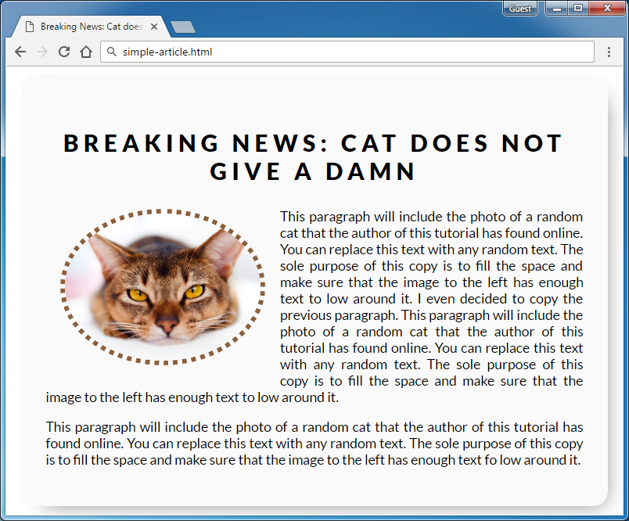

Create two files: "**simple-article.html"** and **"simple-article.css"**

Use **Semantic HTML** to create the page

### Constraints

* <body>
  + font-family:"Lato", sans-serif;[**"https://fonts.googleapis.com/css?family=Lato:300,400,900"**](https://fonts.googleapis.com/css?family=Lato:300,400,900)
* Content
  + Width 550px
  + Border radius15px
  + Center the content
  + Padding 25px
  + Background color #fafafa
  + box-shadow: 10px 11px 35px -14px rgba(0,0,0,0.54)
* <h1> tag for heading
  + Margin bottom 0
  + Padding 10px
  + Text center
  + Letter spacing 5px
* Image
  + Width 200px
  + Border radius 50%
  + Margin 15px
  + Border 5px dotted #8b603d
* Paragraphs
  + Text size 14px

### Hints

Use:

* <p> with text-align:justifyin the CSS file
* <img>with float "**left**"

## Create Header

Create a Web Page like the following:



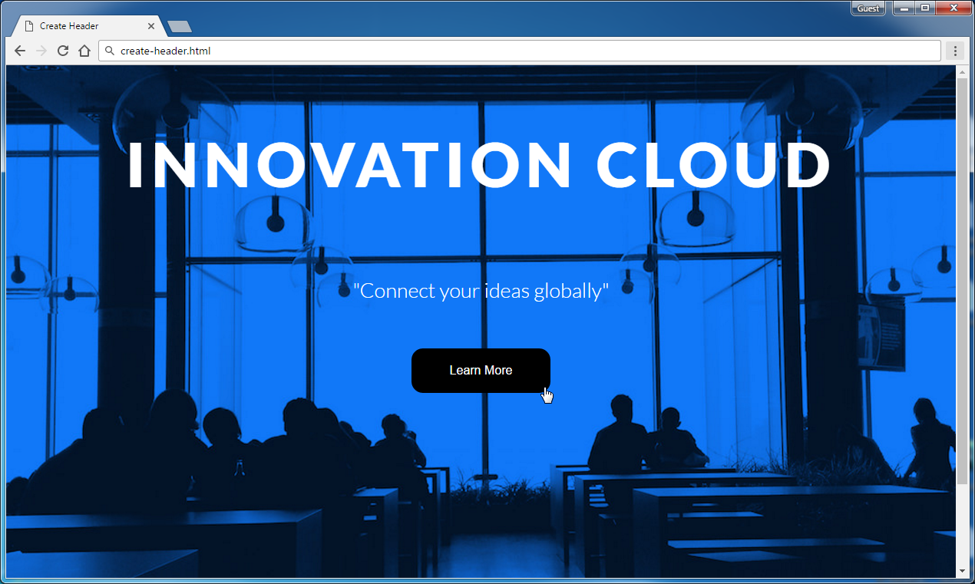

Create two files: "**create-header.html**"and"**create-header.css**"

Use **Semantic HTML** to create the page

### Constraints

* <body>
  + font-family "Lato", sans-serif
  + Text color #ffffff
* <header>with **class="container"**
  + Center the container
  + Padding 0 10px
  + Backgroundurl(image.jpg) no-repeat center center
  + Background size cover
  + Height 800px
  + Text center
* <h1>for heading
  + Text size 80px
  + Padding 80px 0
  + Letter spacing 8px
* Paragraphfor the text
  + Text size 27px
  + Font weigth 100
  + Margin 20px
* <button>with class **bnt** for button
  + Text color #ffffff
  + Background none
  + Border 5px solid #ffffff
  + Border radius 15px
  + Padding 15px 45px
  + Text size 16px
* **Button** on hover
  + Background #000
  + Border color #000
  + Cursor **pointer**

### Hints

Use:

* **\* to reset css**

**\* {**

**Margin 0**

**Padding 0**

**}**

## Create Content

Create a Web Page like the following using **Create-Content.txt**.

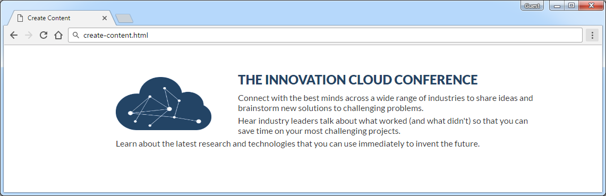

Create two files: "**create-content.html**" and "**create-content.css**"

### Constraints

* Font-family "Lato",sans-serif
* <main>as a **container**
  + Margin 50px auto
  + Max width 1060px
  + Padding 0 10px
* <h2>for heading
  + Text color #234465
  + Margin 10px
* Paragraph
  + Text size 16px
  + Text color #333333
  + Margin bottom5px
  + Letter spacing 0
  + Width800px
* Image
  + Width 180px
  + Height 100px
  + Margin 10px 50px 0 0

## Innovation Cloud

* Create a Web Page like the following.

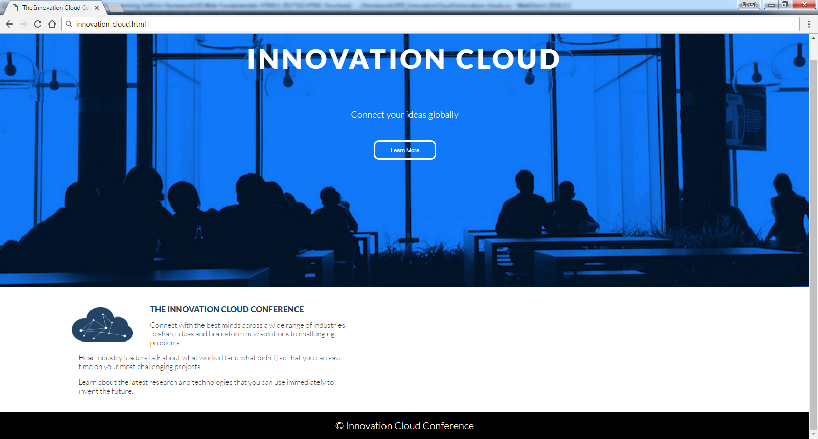

Create two files: "**innovation-cloud.html**"and "**innovation-cloud.css**"

Use **Semantic HTML** to create the page

### Constraints

* **Problem 3 + Problem 4**
* **Footer**
  + **Background color: #000000**
* Text in footer
  + Text color: **#ffffff**
  + Text size: **14px;**
  + Height: **80px;**
  + Line height: **80px;**
  + Margin: **0px;**

## *Conference

Create a Web Page like the following using **conference.txt**

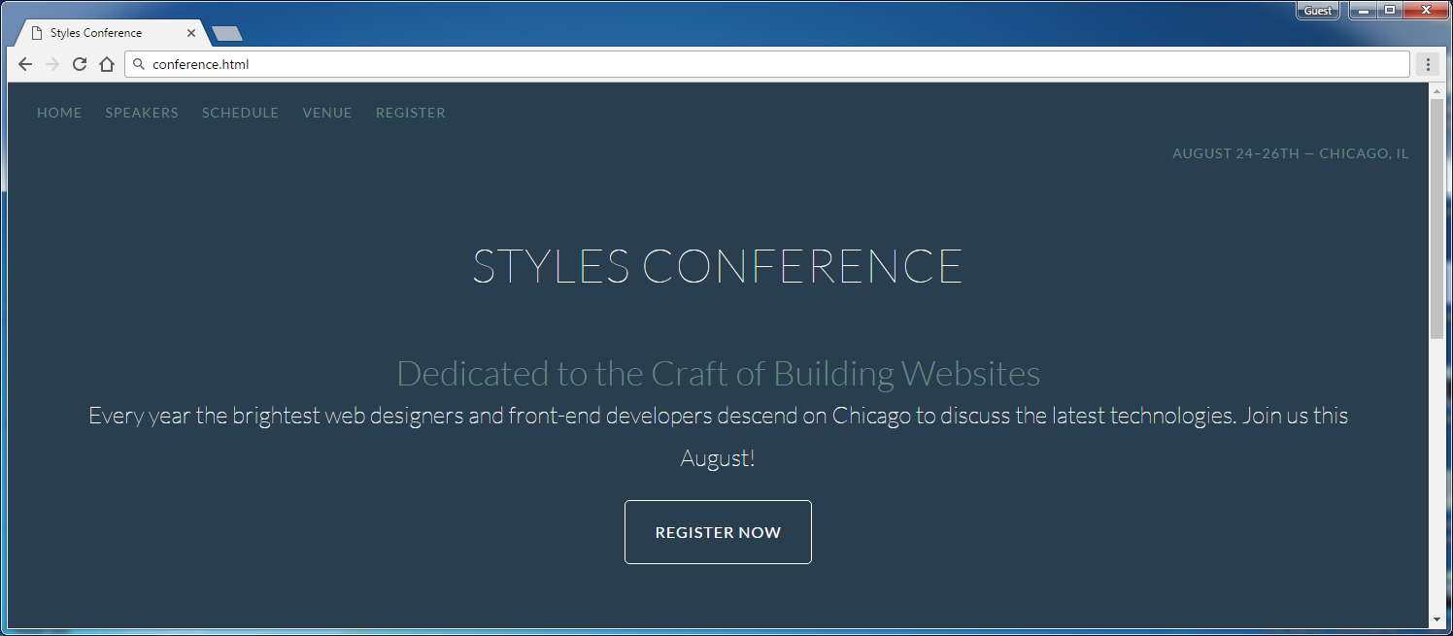

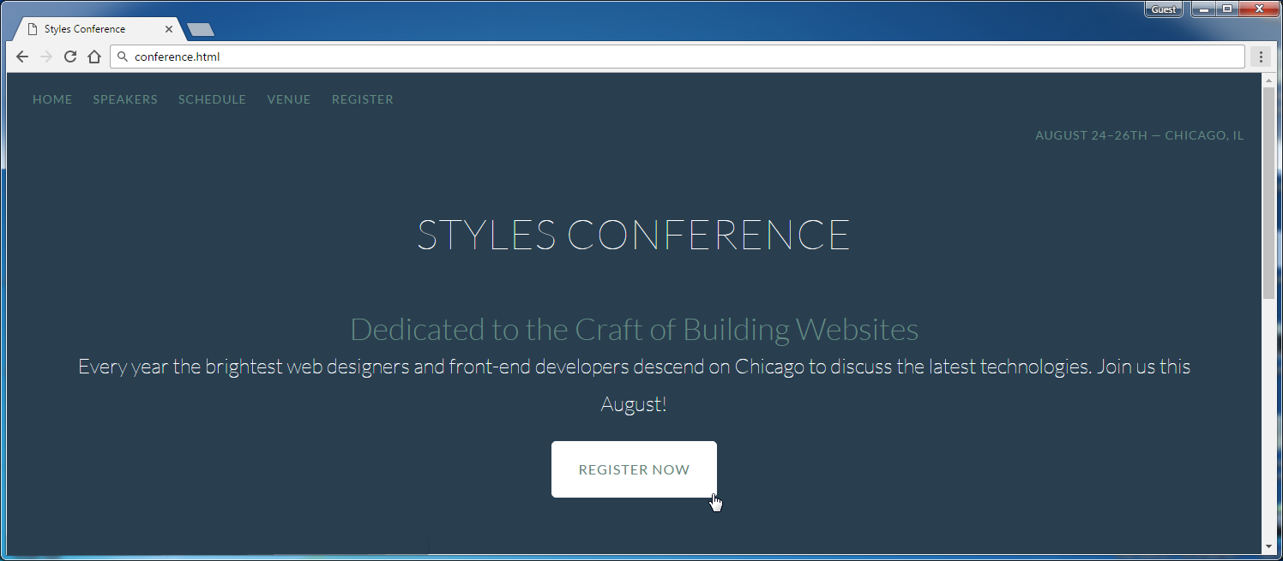

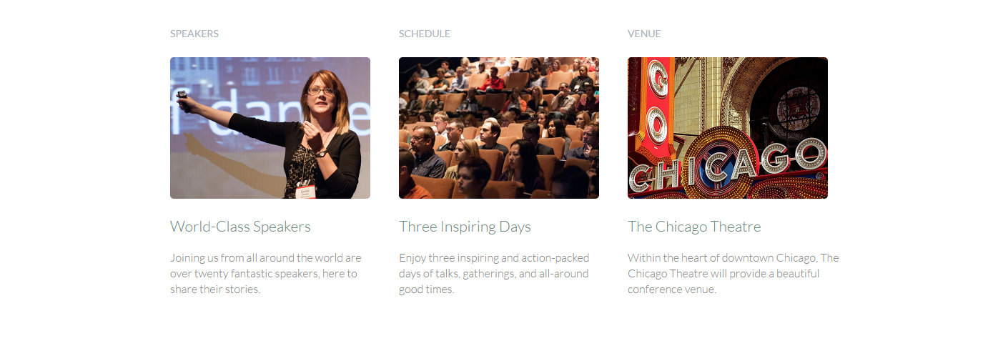



Create two files: "**conference.html**" and "**conference.css**"

Use **Semantic HTML** to create the page

You may use **color picker (search in google)**

### Hints

Use:

* Hyperlink for **button**
* Get font from [here](http://fonts.googleapis.com/css?family=Lato:100,300,400)
* Default font: **300 16px/22px "Lato", sans-serif**

## Table

Create a Web Page like the following using **table.txt**

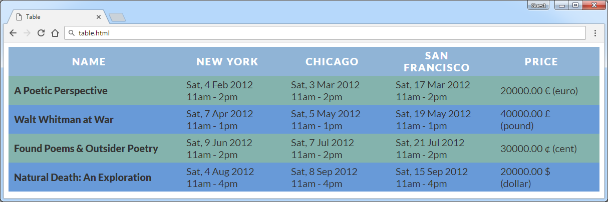

Create two files: "**table.html**" and "**table.css**"

Use **Semantic HTML** to create the page

### Constraints

* Font-family "Lato", sans-serif
* Table
  + Text color #333333
  + Border spacing none
  + Center the **table**
* Table headings
  + Text color #ffffff
  + Background color #90b4d6
  + Center the text
  + Letter spacing 2px
* Table headingfor bold text
  + Padding 5px 30px 5px 10px
  + Text size 18px
  + Margin 0
  + Text align **left**
  + Background color #84b3ad
* Table data
  + Padding 5px 30px 5px 10px
  + Text size 18px
  + Margin 0
  + Text align **left**
  + Background color #84b3ad
  + Width 150px

### Hints

Use:

* **tr:nth-child(even) td, tr:nth-child(even) th** { Background color **#689ad8**

}

* Search internet for currency symbols **(HTML entities)**

## Book Store

Create a Web Page like the following using **book-store.txt**

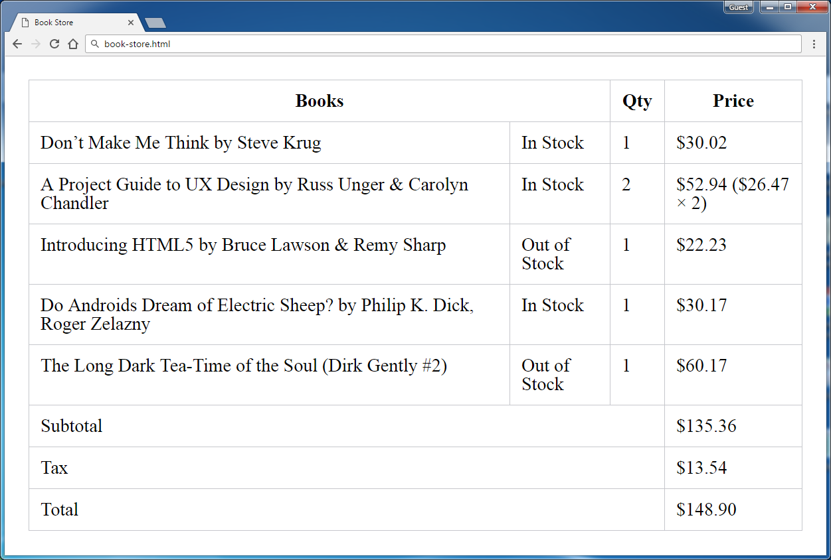

Create two files: "**book-store.html**" and "**book-store.css**"

Use **Semantic HTML** to create the page

### Constraints

* Border Color: #c6c7cc

### Hints

Use:

* **&#8217;** for **apostrophe**
* Reset the CSS file
* Search internet for currency symbol and other special symbols like **&** **(HTML entities)**